Extraction

* Say you have two compounds, make sure only one becomes protonated/ deprotonated after addition of acid/ base so that it gets extracted into the aqueous layer, while the other neutral compound gets extracted into the organic layer
* Example
  + Strong acid (e.g. carboxylic acids, anhydride) can be deprotonated using a strong base or a weak base; do not use acid to try and protonate another acid
  + Weak acid (e.g. phenol) can only be deprotonated using a strong base

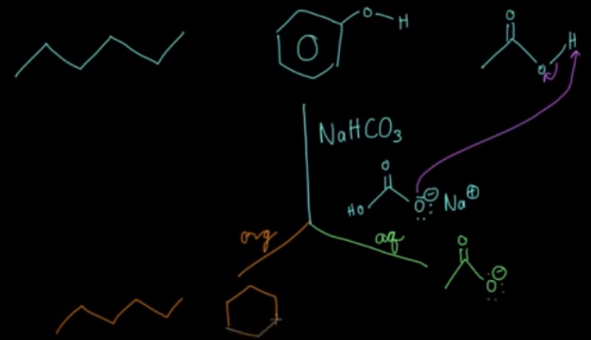

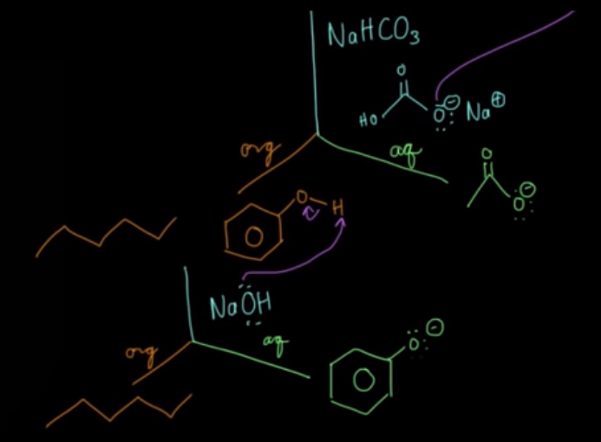

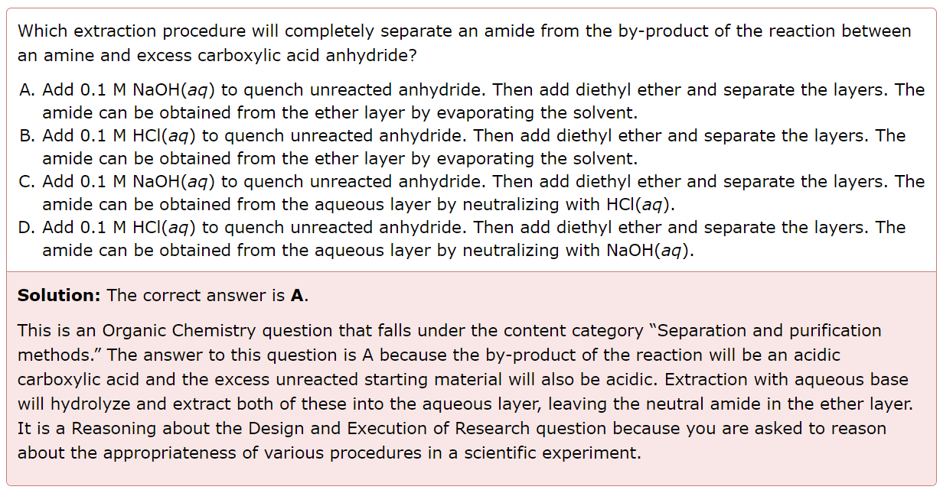

Separation vs Analytical Techniques

* Extraction is a separation technique
  + E.g. Separation of separating 2-methylundecanal (neutral) and 2-methylundecanoic acid can be separated based on their differing solubilities
  + Can be done using careful extraction with a dilute weak base (e.g. sodium bicarbonate)
  + Remember that the more polar a compound is, the higher its solubility in aqueous solution
* Differences in plane polarized light, mass spectrometry, and different scent profiles etc are analytical techniques

Chemical Structure of biologically-relevant molecules

1. Pyrophosphate

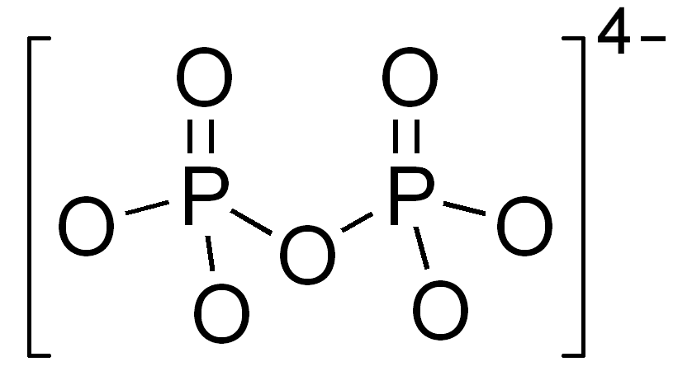

1. Triacylglycerol/ triglyceride
   1. 3 FAs bound to a glycerol

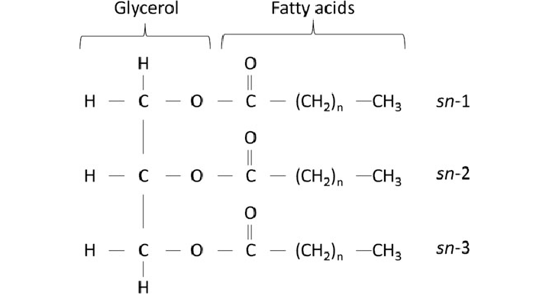

1. Phosphatide/ phosphoglyceride
   1. One FA replaced with a phosphate which can be bound to another group e.g. choline (shown below is a phosphatidylcholine)
   2. Therefore, two FAs and one phosphate bound to glycerol

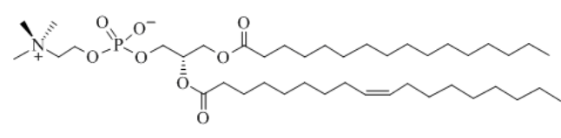

Naming convention of phosphates in ATP

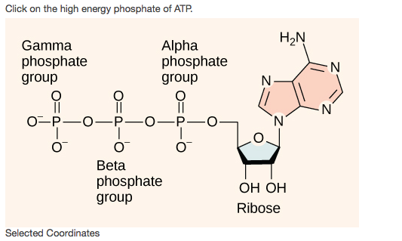

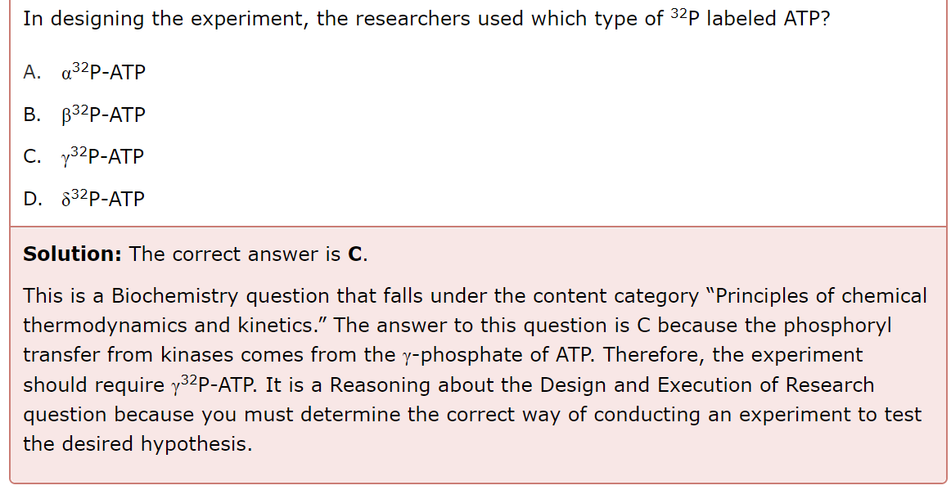

E/Z IUPAC naming

* Sometimes cis/ trans is used but limited

1. Find the longest carbon chain first
2. Locate the two highest priority groups on each carbon (of the double bond)
3. Determine if the two groups are on the same side
   1. Same side (Z)
   2. Different sides (E)

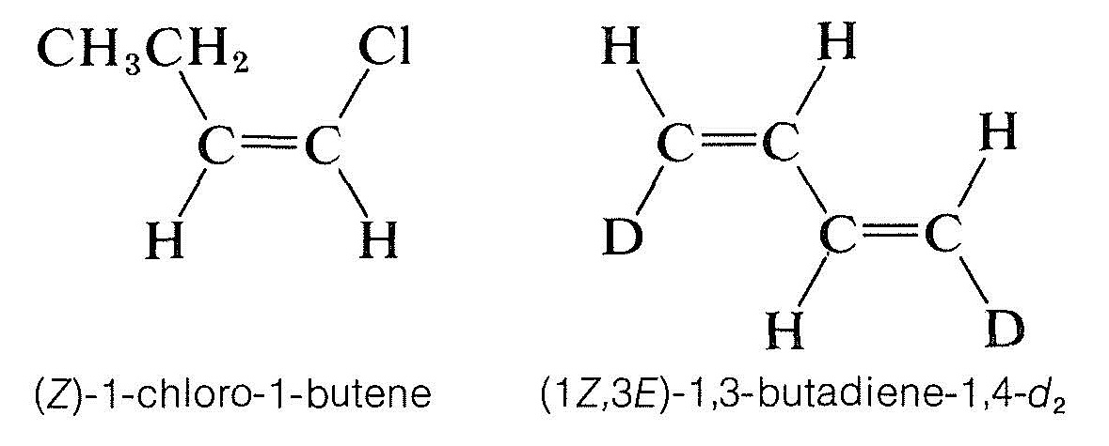

Heterocyclic Aromatic Systems

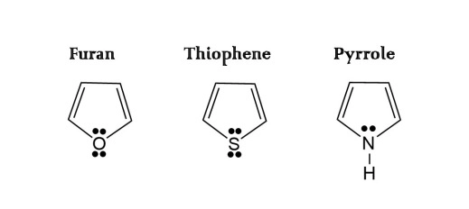

Nitrogen-containing compounds

* An amine is defined as R3N, where R = H or a carbon group (but NOT C=O) and no more than two out of three R groups can be H
* An imine has the structure R2C=NR, where R = a carbon group or H
* An amide has the structure R1(C=O)NR2R3

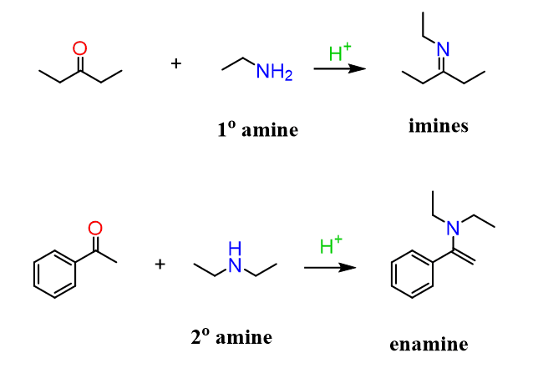

Charge on Histidine

* AAMC considers Histidine as neutral and exists as a zwitterion at **physiological pH**
  + If no pH is mentioned in the question stem, you can probably assume that Histidine side chain can carry a positive charge (which is important for questions that ask for favorable ionic interactions e.g. with negatively charged phosphates of ADP)
* As a side note to the question, the stationary phase of an anion-exchange column consists of cations, which attract anions. Also, the stronger the interaction between the substrate (i.e. negatively charged peptides) and the stationary phase, more elution volume is required to displace the peptides

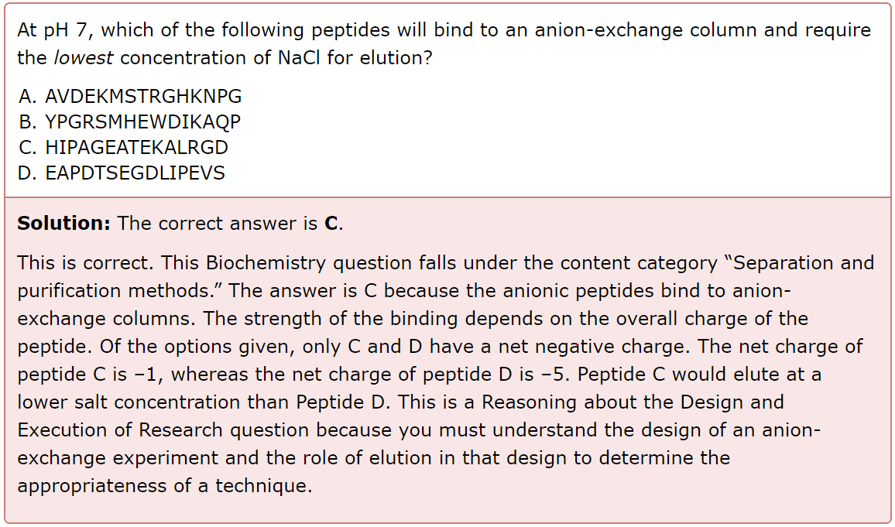

Enzyme Cooperativity

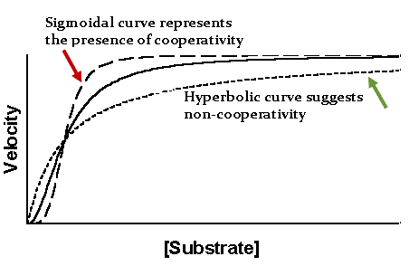

Multiple Substrate Binding Mechanism

1. Sequential (ternary complex is formed)
   1. Random (either substrate could bind first)
   2. Ordered (one substrate binds first without catalysis, then the other substrate binds)
2. Ping-Pong/ Double displacement (intermediate complex is formed; NO ternary complex is formed)

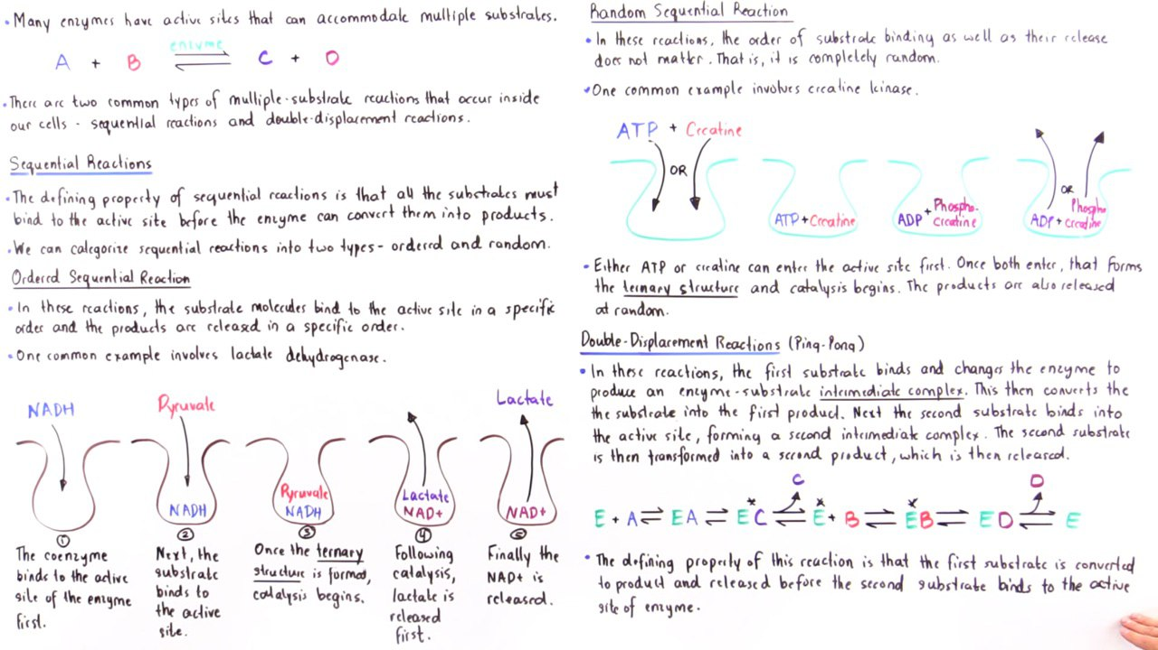

Phosphorylation

* Serine, Threonine and Tyrosine can be phosphorylated due to the presence of hydroxyl groups
* Know that the oxygen (in this case) is the nucleophile, and the phosphate is the electrophile

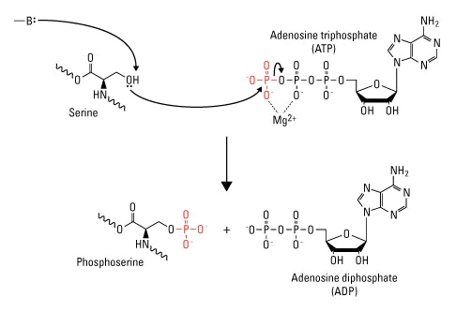

Good Buffer

* A good buffer has a p*K*a within **1 pH** unit of the desired experimental conditions
* E.g. When choosing a buffer to use for an experiment conducted at pH 5.3, it is best to choose one with a pKa between 4.3 and 6.3

Entropic Penalty

* When a protein is in its folded conformation you expose certain amino acids to the aqueous environment. Typically the core of the protein is hydrophobic and the aqueous environment is hydrophilic.
* However, if a protein has a particular conformation that requires certain hydrophobic amino acids to be exposed to the aqueous environment, this will yield a loss of entropy AKA entropic penalty because the interaction is unfavorable.

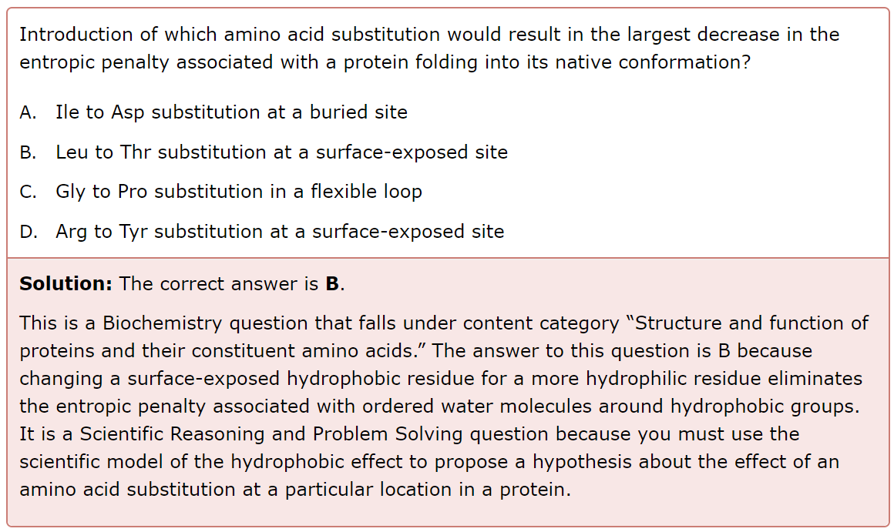

1. I → D substitution at a buried site would increase entropic penalty because the core of the protein is hydrophobic
2. Choice B is the only answer choice that decreases entropic penalty because threonine is more polar than leucine. This corresponds to a greater **decrease** in entropic penalty.
3. G → P substitution at a flexible loop would make the loop not so flexible anymore, increasing entropic penalty (because glycine is very flexible and proline is very rigid due to its imine structure)
4. R → Y substitution at a residue exposed to the aqueous environment would increase entropic penalty because tyrosine is hydrophobic

Hydrophobic Effect

* Occurs when the hydrophobic groups cluster together
* This increases entropy because of a greater degree of hydrogen bond network in the water solvent, or less interruption by nonpolar protein groups
* This also means that the Gibbs value decreases, which is favorable

Water vs Ice

* For most substances, the liquid becomes more dense as the average kinetic energy (temperature) decreases, and the solid is more dense than the liquid due to close-packing solid-state structures, resulting in the formation of the solid at the bottom of the liquid.
* However, solid water (ice) is significantly less dense than the liquid form at 0°C (the melting/freezing point). Remember, the water molecule is bent, with a bond angle of approximately 104.5°. This, combined with the degree of hydrogen bonding that can occur between water molecules, yields a solid crystalline structure with relatively large amounts of empty space. As a result, solid water is less dense than its liquid form.

Boiling occurs when Pvap = Patm

* Adding salt reduces the vapor pressure of the liquid
  + Specifically, as the solute concentration is increased, the rate at which water molecules can break through the liquid surface decreases.
  + Remember that boiling point is defined as the temperature at which the vapor pressure of a solution is equal to the atmospheric pressure.
  + A decrease in vapor pressure makes this point more difficult to achieve, resulting in a higher boiling temperature.
* In vacuum distillation, vapor pressure is reduced
  + The boiling point is also reduced

Intermolecular Interaction vs Intramolecular Interaction

* Boiling points are more indicative of intermolecular forces
* Stability of a molecule is about intramolecular covalent bonds (between atoms of a molecule), and when it combust you are breaking those bonds.

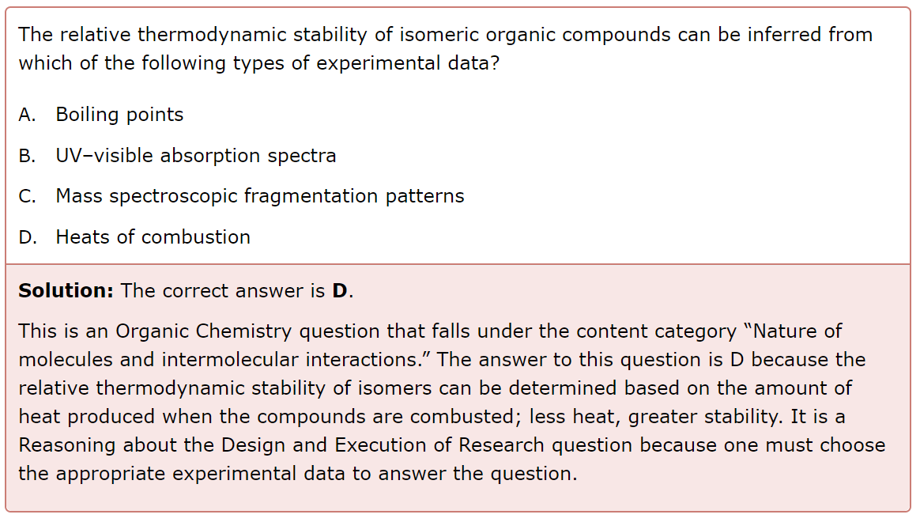

Carbocation Formation

* The rate of cation formation through loss of a hydrogen atom is directly related to the energy required to remove a hydrogen atom from the compound.
  + The more energy (△Hf for X → X+) required, the slower the rate

Order of Elution in Chromatography

* Usually the stationary phase is polar, and the mobile phase is nonpolar
* Hence, the compound with weakest force of attraction with the stationary phase (e.g. LDF only) will be eluted first

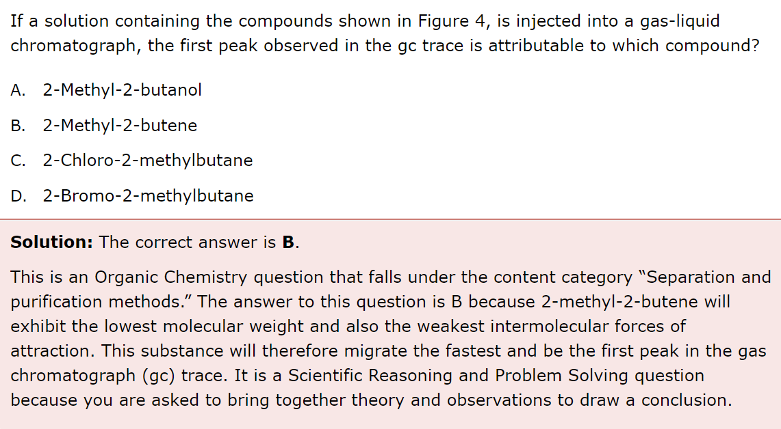

Fatty Acids

* Solubility in water decreases as the length of the hydrocarbon chain increases
* E.g. CH3(CH2)10COOH will be more soluble in water than CH3(CH2)16COOH

Complex Carbohydrates

* Disaccharides:
  + Sucrose = glucose-α-1,2-fructose
  + Lactose = galactose-β-1,4-glucose
  + Maltose = glucose-α-1,4-glucose

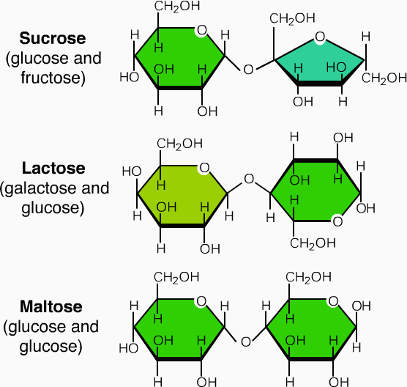

* Polysaccharides:
  + Glycogen = glucose-α-1,4-glucose + glucose-α-1,6-glucose
  + Starch = glucose-α-1,4-glucose
  + Cellulose = glucose-β-1,4-glucose

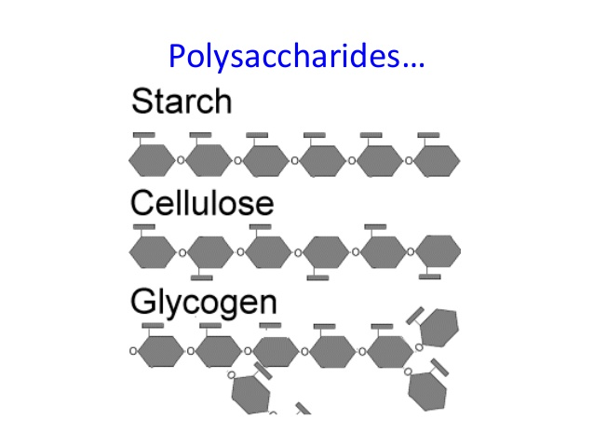

Total Internal Reflection

* Can only result when a ray of light begins in a higher-index material and reaches a boundary with a lower-index one (e.g. starting in water and moving towards air)
* *n*1sin(*θ*1) = *n*2sin(*θ*2), where *θ*2 = 900 and *n*1 = 1 (for air)
  + Hence, critical angle *θ*c = *sin-1(n*2 / *n*1)

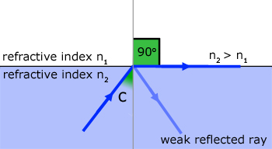

Myopia

* In people with myopia, or nearsightedness, light rays entering the eye converge in too short a distance, causing the image of an object at infinity to be focused within the vitreous humor, before the light reaches the retina
  + Problem: ciliary muscle cannot sufficiently relax → lens has a more spherical shape → more focusing power → converge in front of the retina
  + Solution: have a diverging lens in front of the eye

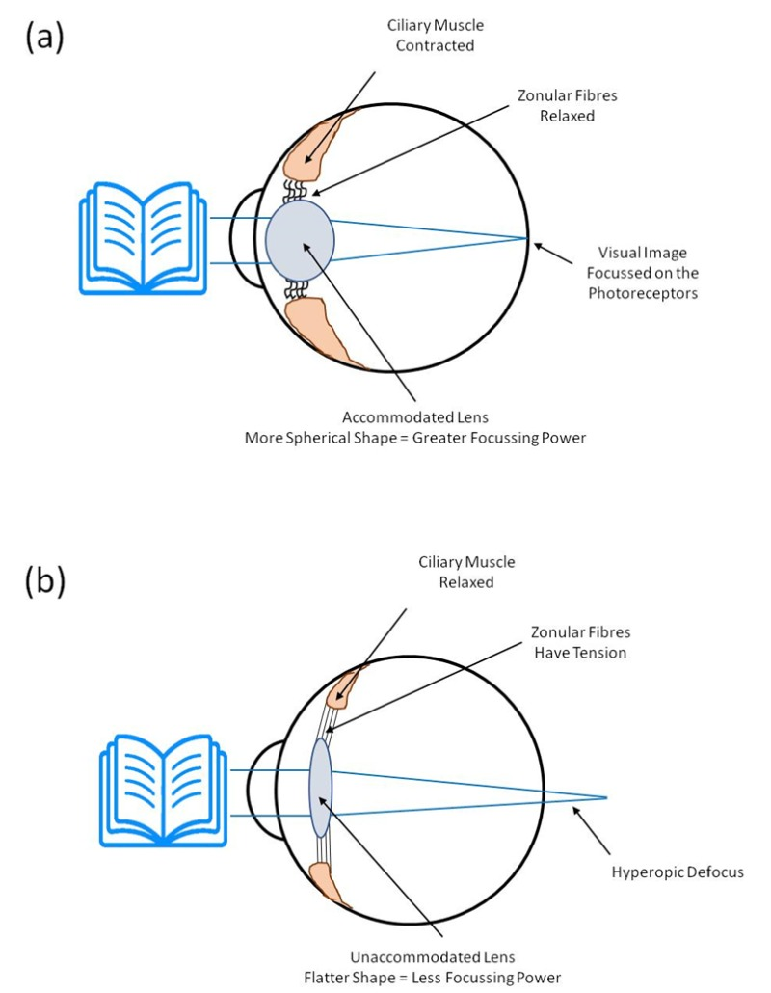

Application of Bernoulli Equation

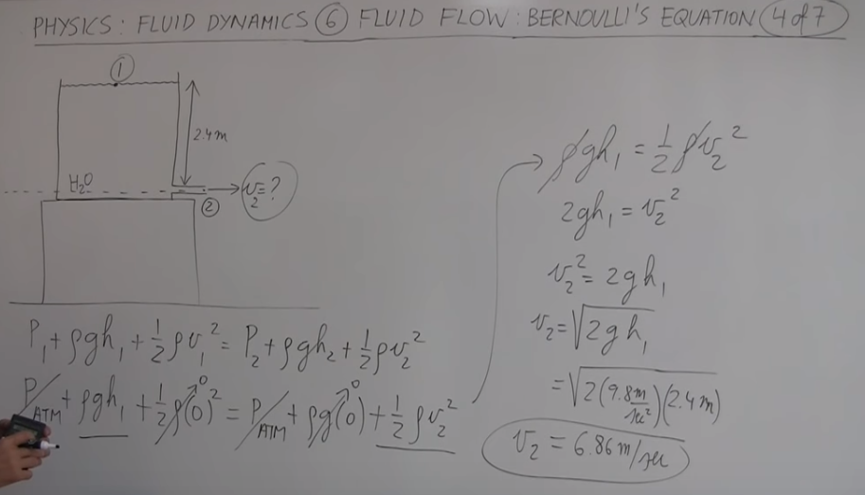

Resistivity

* Directly proportional to temperature
* For a constant voltage, if the temperature increases by a factor of F, then the resistivity (and hence resistance) increases by a factor of F, so the current must decrease by a factor of F

Archimedes Principle

* ρobj / ρfluid = Fg / Fb
* Intuition: if the object’s density is more than fluid’s density, then the object’s weight is greater than the buoyancy force and so the object will sink
* Fb = apparent loss of weight = Wair - Wfluid = ρfluid g Vdisplaced fluid

Battery Capacity

* Amps (A) is a measure of current
* Ah, mAh (Q = It) is a measure of charge capacity
  + E.g. 10 Ah means you can deliver 1A for 10 hours
  + 10 Ah also means you can deliver 2A for 5 hours, etc
  + Hence, total charge a battery can deliver is 10A x 1h = 10C/s x 3600 s = 36kC
* Wh (E = Pt = VIt = QV) is a measure of energy capacity

Quick math calculations

* E = hc/λ (E = hf) → E = 1eV = 1.6 x 10-19J when λ = 1250nm (f = 2.4 x 1014 Hz)